Annex E

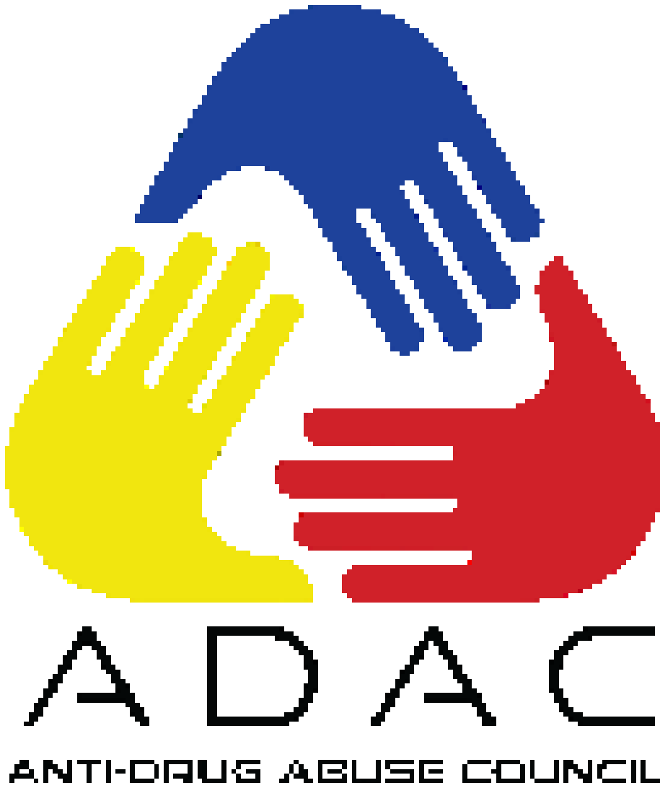

Republic of the Philippines
DEPARTMENT OF THE INTERIOR AND LOCAL GOVERNMENT
DILG-NAPOLCOM Center, EDSA corner Quezon Avenue, Quezon City
www.dilg.gov.ph

DILG PHILIPPINE ANTI-ILLEGAL DRUGS STRATEGY -
PROJECT MANAGEMENT OFFICE

2019 and 2020 Anti-Drug Abuse Council
Performance Audit and Awards

PACKAGING OF DOCUMENTS

Republic of the Philippines
DEPARTMENT OF THE INTERIOR AND LOCAL GOVERNMENT
DILG-NAPOLCOM Center, EDSA corner Quezon Avenue, Quezon City
www.dilg.gov.ph

PACKAGING OF AUDIT DOCUMENTS FOR REGIONS

Republic of the Philippines
DEPARTMENT OF THE INTERIOR AND LOCAL GOVERNMENT
DILG-NAPOLCOM Center, EDSA corner Quezon Avenue, Quezon City
www.dilg.gov.ph

- Document Checklist 2 Cover Page Template
  - The Provincial MOVs should be compiled and submitted in a comb-bound form. It should follow the prescribed cover page as shown below:
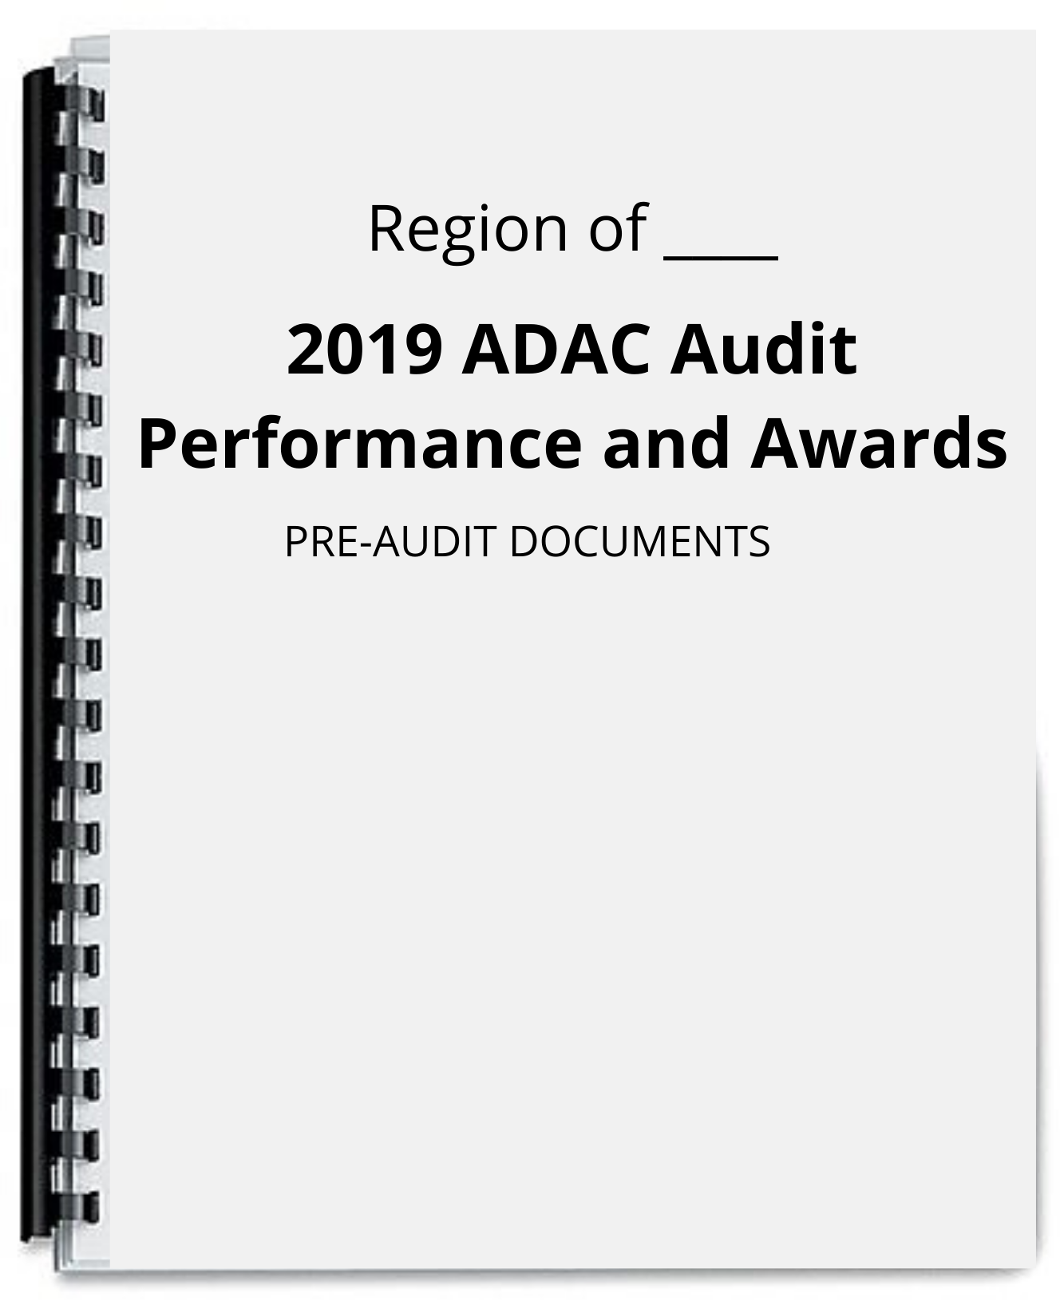

- Table of Contents for Provincial, Cities, and Municipalities MOVs
The Following shows the prescribed Table of Contents for the Provincial, Cities, and Municipalities MOVs.

TABLE OF CONTENTS (DOCUMENT CHECKLIST 2)

- Indicator 1: Creation / Reorganization of ADAC
1.1 Executive Order or Local Ordinance containing the creation or reorganization of the Anti-Drug Abuse Council.
- Indicator 2: Allocation of substantial amount as indicated in the ADAC Plan
2.1 ____ Approved POPS Plan
2.2 Local Annual Budget
2.3 Local Annual Investment Plan
2.4 ____ Certification from the Budget Officer re: Allocation of funds for the implementation of Anti-Illegal Drug Activities or for the activities in the POPS Plan
- Indicator 3: Implementation of Plans and Programs
3.1 Certification from Accountant re: Fund Utilization on Anti-Illegal Drug campaign
3.2 ADAC Annual Accomplishment Report signed by Governor
3.3 Certification from PDEA/Regional Oversight Committee (ROC) stating the following:
3.3.1 Number of Drug-Affected Barangays within the City/Municipality as of end of ____.
3.3.2 Number of Drug-Cleared Barangays within the City/Municipality as of end of ____.
3.3.3 Number of Drug-Affected Barangays within the City/Municipality as of end of ____.
3.3.4 Number of Drug-Cleared Barangays within City/Municipality as of end of ____.
3.4.5 Or if applicable, Certification from PDEA that City/Municipality has achieved/maintained Drug-free status in ____.
3.4 Documentation of SDEC Facilities / Program or any equivalent documents.
3.5 Activity Design of all implemented Anti-Illegal Drug Activities for all quarters.
4.6 Post-Activity Reports for all implemented Anti- Illegal Drug Activities for all Quarters
- Indicator 4: Support to ADACs in component LGUs
4.1 Summary of Performance Audit Results Endorsed by APT.
4.2 Executive Order OR Certification from the accountant regarding the financial support given to the component C/MADACs
4.3 Executive Order OR Terminal Report regarding the technical support given to the component C/MADACs
5.3.1 Certificate of Recognition from Component C/MADACs in relation to support/provided for Anti-Illegal Drug Activities
- Indicator 5: Conduct of quarterly meetings

5.1 Notice for Quarterly meetings
5.2 Minutes of Quarterly meetings conducted
- Indicator 6: Innovations
6.1 For LGU – Initiated Activities/Facility/Program:
6.1.1 Interviews
6.1.2 Articles
6.1.3 Report Initiative
6.2 For ADAC Member Agency – Initiated Activity/Facility/Program
6.2.1 ADAC Member Agency report on initiative
6.2.2 ADAC Resolution endorsing ADAC member agency initiative
6.3 For CSO – Initiated Activity/Facility/Program
6.3.1 CSO Report on initiative
6.3.2 ADAC Resolution endorsing CSO initiative

- Reference for Tabbing for the Provincial, Cities, and Municipals MOVs
The Numbers marked with red are the ones to be used in tabbing all of the
Provincial, Cities, and Municipals MOVs.
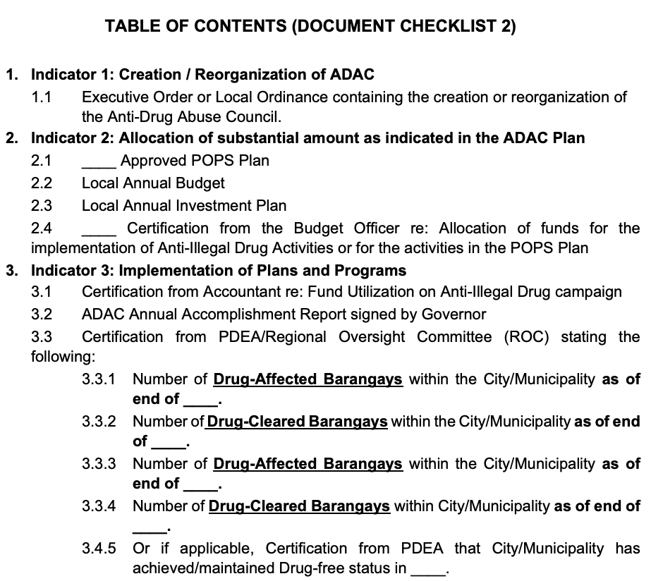

- Order of Documents for the Submission of Document Checklist 1
The order of the Document Checklist 2 to be submitted should be as follows:

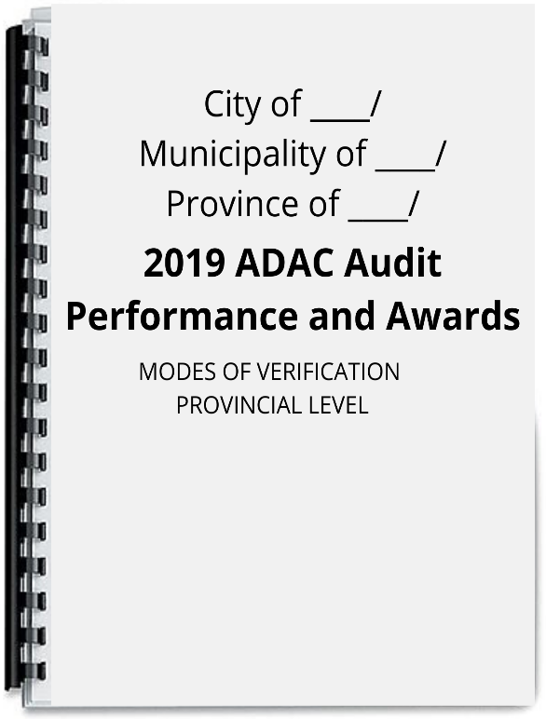
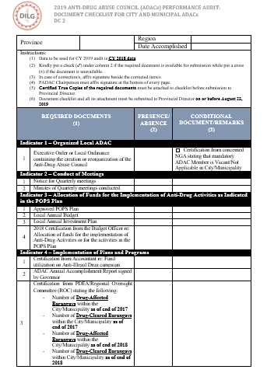
1. 2.

Cover Page Document Checklist
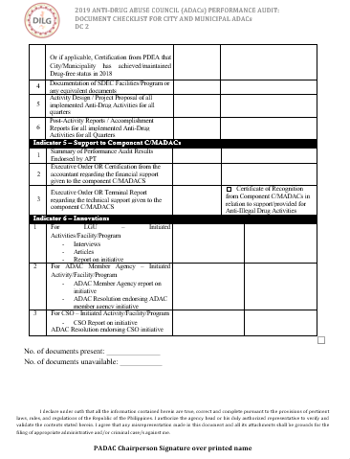
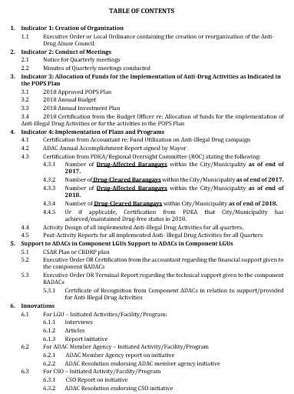

- 4.

Document Checklist 2 Table of Contents
(Continuation)

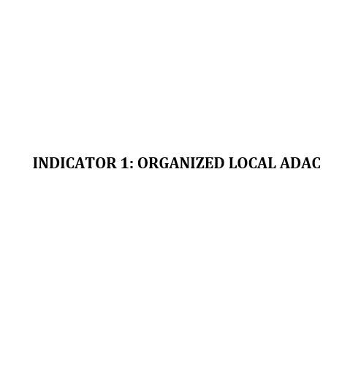

5. 6.

Indicator 1 Cover Indicator 1.1 Document

- Regional Performance Documents Cover Page Template
The Regional Performance Documents should be compiled and submitted in a comb-bound form. It should follow the prescribed cover page as shown below:

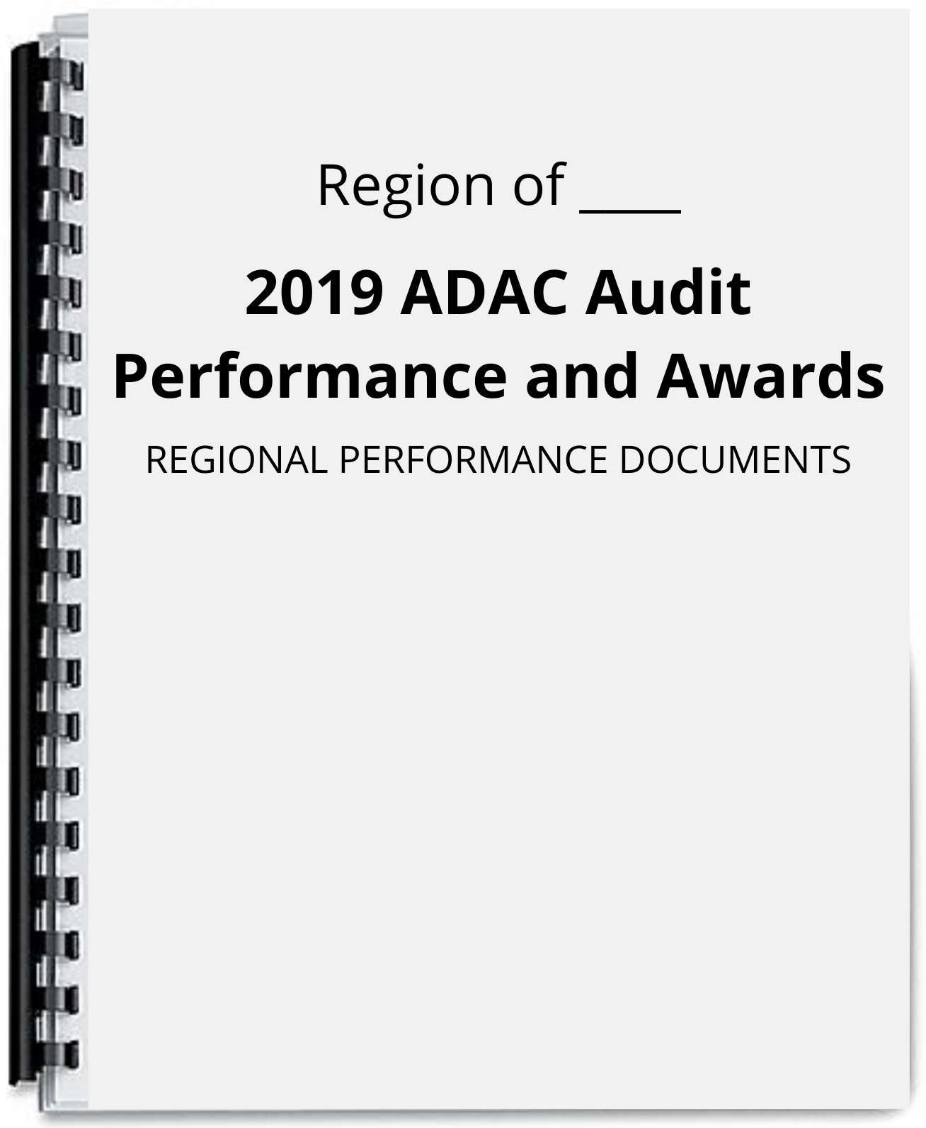

- Table of Contents for the Regional Performance Documents
The Following shows the prescribed Table of Contents for the Regional Performance Documents.

TABLE OF CONTENTS
(Regional Performance Documents)

      - Province A
  - Province A report of Audit Result

      - Province B
2.1 Province B report of Audit Result

      - Province C
  - Province C report of Audit Result

      - Province D
  - Province D report of Audit Result

      - Province E
5.1 Province E report of Audit Result

      - Province F
6.1 Province F report of Audit Result

- Reference for Tabbing for the Regional Performance Documents:
The numbers marked with red are the ones to be used in tabbing all of the pre-audit documents.

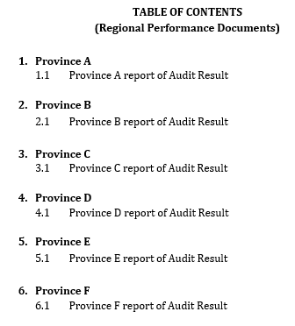

- Order of Documents for the Submission of Regional Performance Documents
The order of the Regional Performance Documents to be submitted should be as follows:

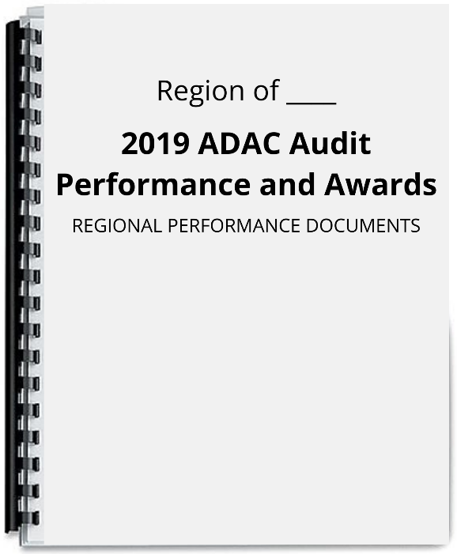
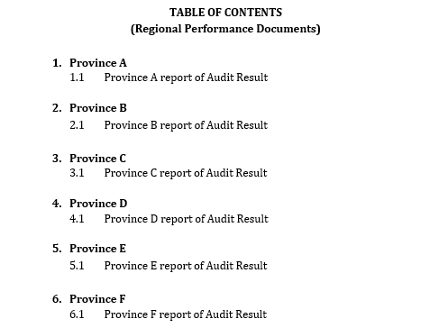
1. 2.

Cover Page Table of Contents

3. 4.

Province A Cover Page Provincial Audit Result

Republic of the Philippines
DEPARTMENT OF THE INTERIOR AND LOCAL GOVERNMENT
DILG-NAPOLCOM Center, EDSA corner Quezon Avenue, Quezon City
www.dilg.gov.ph

PACKAGING OF AUDIT DOCUMENTS FOR PROVINCES, CITIES AND MUNICIPALITIES

- Document Checklist 1 Cover Page Template
The Document Checklist 1 should be compiled and submitted in a comb-bound form. It should follow the prescribed cover page as shown below:

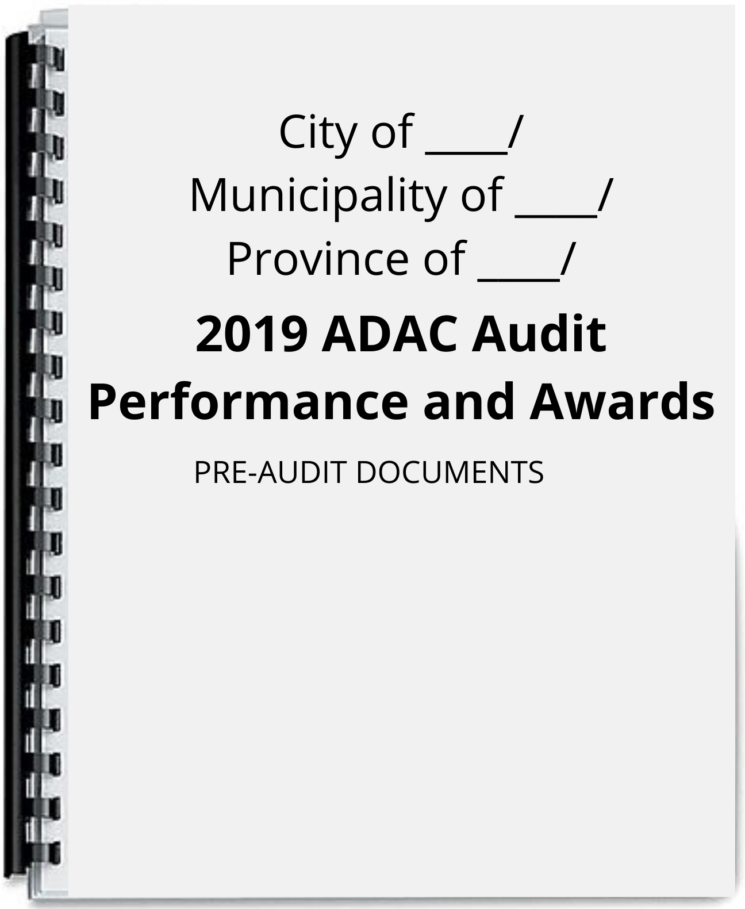

- Table of Contents for Document Checklist 1
The prescribed Table of Contents for Document Checklist 1 are as follows:

TABLE OF CONTENTS (DOCUMENT CHECKLIST 1)

- Indicator 1: Creation / Reorganization of ADAC
  - Executive Order or Local Ordinance containing the creation or reorganization of the Anti-Drug Abuse Council.
    - Certification from concerned NGA stating that mandatory ADAC Member is Vacant / Not Applicable in City / Municipality.
- Indicator 2: Allocation of substantial amount as indicated in the ADAC Plan
2.1 ____ Approved POPS Plan
2.2 ____ Annual Budget
2.3 ____ Annual Investment Plan
2.4 ____ Certification from the Budget Officer re: Allocation of funds for the implementation of Anti-Illegal Drug Activities or for the activities in the POPS Plan
- Indicator 3: Implementation of Plans and Programs
3.1 Certification from Accountant re: Fund Utilization on Anti-Illegal Drug campaign
3.2 ADAC Annual Accomplishment Report signed by Mayor
3.3 Certification from PDEA/Regional Oversight Committee (ROC) stating the following:
3.3.1 Number of Drug-Affected Barangays within the City/Municipality as of end of ____.
3.3.2 Number of Drug-Cleared Barangays within the City/Municipality as of end of ____.
3.3.3 Number of Drug-Affected Barangays within the City/Municipality as of end of ____.
3.3.4 Number of Drug-Cleared Barangays within City/Municipality as of end of ____.
3.4.5 Or if applicable, Certification from PDEA that City/Municipality has achieved/maintained Drug-free status in ____.
3.4 Activity Design of all implemented Anti-Illegal Drug Activities for all quarters.
3.5 Post-Activity Reports for all implemented Anti- Illegal Drug Activities for all Quarters
- Indicator 4: Support to ADACs in Component LGUs
4.1 CSAR Plan or CBDRP plan
4.2 Executive Order OR Certification from the accountant regarding the financial support given to the component BADACs
4.3 Executive Order OR Terminal Report regarding the technical support given to the component BADACs
4.3.1 Certificate of Recognition from Component ADACs in relation to support/provided for Anti-Illegal Drug Activities

- Indicator 5: Conduct of quarterly meetings
5.1 Notice for Quarterly meetings
5.2 Minutes of Quarterly meetings conducted
- Indicator 6: Innovations
6.1 For LGU – Initiated Activities/Facility/Program:
6.1.1 Interviews
6.1.2 Articles
6.1.3 Report Initiative
6.2 For ADAC Member Agency – Initiated Activity/Facility/Program
6.2.1 ADAC Member Agency report on initiative
6.2.2 ADAC Resolution endorsing ADAC member agency initiative
6.3 For CSO – Initiated Activity/Facility/Program
6.3.1 CSO Report on initiative
6.3.2 ADAC Resolution endorsing CSO initiative

- Reference for Tabbing for the Document Checklist 1
The numbers marked with red are the ones to be used in tabbing all of the pre-audit documents.
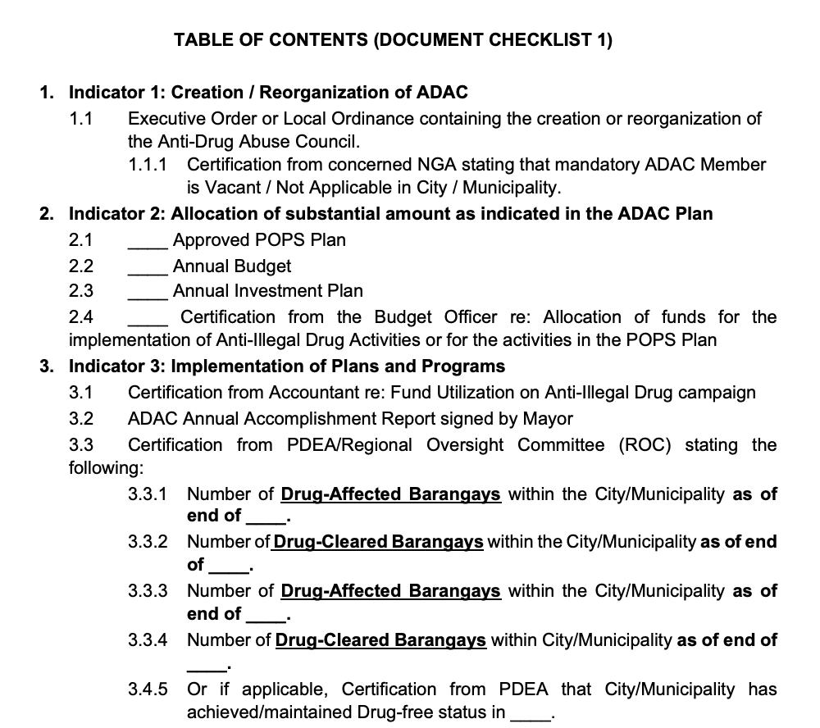

- Order of Documents for the Submission of Document Checklist 1
The order of the pre-audit documents to be submitted should be as follows:
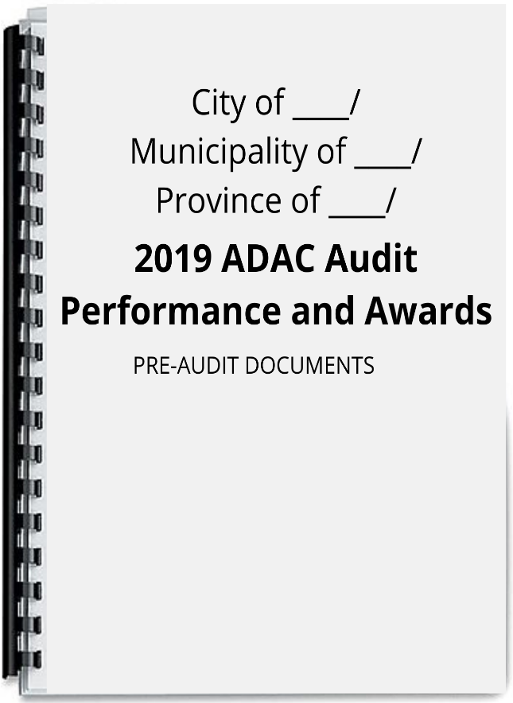
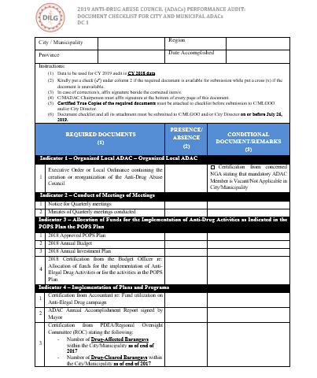

1. 2.

Cover Page Document Checklist
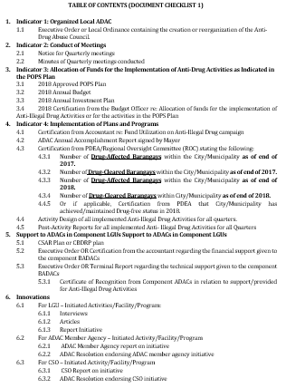

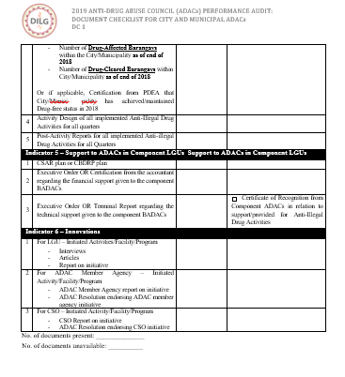
3. 4.

Document Checklist 1 Table of Contents
(Continuation)

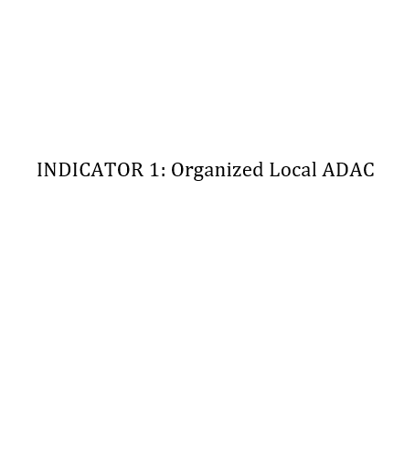
5. 6.

Indicator 1 Cover Page Indicator 1.1 Document

